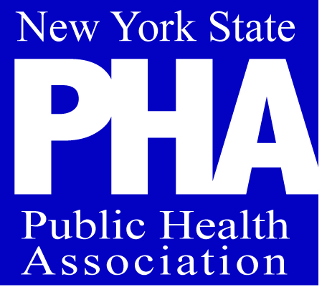 | New York State Public Health Association  PO BOX 8127  Albany, NY 12203  Ph 518 427-5838  info@nyspha.org  www.NYSPHA.org
Member Name:_________________________________________________
Organization Name: _____________________________________________
Home Address: ______________________________________________________
______________________________________________________
County: _____________________________________
Phone: ______________________________________
Email: _______________________________________
Are you an APHA member? ________ If yes, what is your APHA #? _________________
 |  | description |  |  | amount
Please check one:
- Student Membership………………………………………....$ 25
- Reduced Income Membership …………………………………..$ 40
- Indvividual Membership ………………………………...$ 75
- Organizational Membership……………………………$ 250

SUBTOTAL
Balance Due

Please return your Membership Renewal Dues to:
NYSPHA
Attn: Membership

PO BOX 38127

Albany, NY 12203

Please return one copy of invoice with your payment. Thank you!
Questions? Contact us at 518-427-5835 or info@nyspha.org

Make all checks payable to: New York State Public Health Association

THANK YOU!

