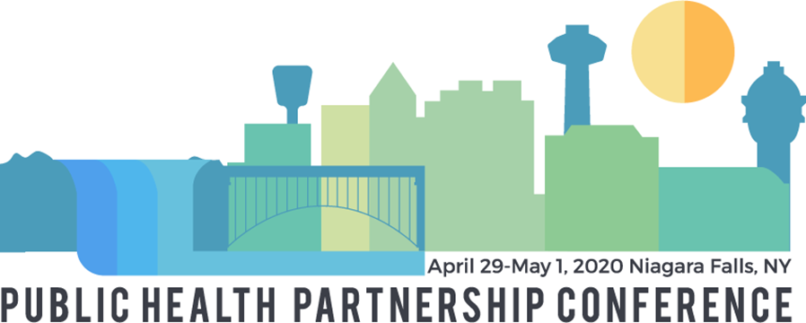
We are excited to be partnering again with the New York State Association of County Health Officials for our 2020 conference and are excited to welcome the NYS Conference on Environmental Health Directors as a new partner!
The Conference & Event Center Niagara Falls 300 3rd St. | Niagara Falls, NY 14303

Air, Water, Food: Protecting Where We Live, Work, and Play
2020 Student Poster Competition
Are you a student at a New York (or surrounding) University or College?
Are you passionate about public health?
Do you have an interesting paper, project or research study to share that has not been previously presented?
Are you competitive and wish to represent yourself and your school?
If so then you should apply for the 2020 student poster competition!
Date: May 1st, 2020
Time: 8:00-11:00 AM
Awards: 11:30-11:45 PM

Here is your chance to compete with other students from public health programs in New York (and surrounding states) to highlight and share a health promotion / prevention issue with other professionals across New York.
Design a poster that has a specific focus in public health; following the theme of the 2020 NYSPHA, NYSACHO and CEHD Public Health Partnership Conference: Air, Water, Food: Protecting Where We Live, Work, and Play, or an area of interest to you and relevant to other conference attendees.
Specifically, we are accepting student poster abstracts for presentations on the following topic areas:
- Air (tobacco, asthma, climate change.)
- Water (drinking water, emerging contaminants, HABs, sugar-sweetened beverages)
- Food (insecurity, breastfeeding, food safety and sourcing)
- Housing/Built Environment (lead, walkable communities, complete streets)
- Environmental Health- Innovations in Policy & Practice

Posters will be judged by NYSPHA Board Members on the following criteria: relevance to the conference theme, engaging for public health professionals, originality, educational value, and overall presentation.
Student posters will be selected for display at the conference from all submitted entries. Students who are selected to display posters will receive a free conference registration for Day 2 of the conference (May 1st) and a $50 travel stipend. Students who wish to attend Day 1 of the conference (April 30th) can register at the discounted student rate of $45. First, Second and Third place winners will each receive a free one-year membership to NYSPHA. The first place winner and the school that he/she is representing will also be acknowledged on NYSPHA’s website. All winners will be awarded before the luncheon. If your poster is selected for display, you must attend the conference to present your poster.
To enter simply complete the entry form and follow the instructions for submission. Entry forms must be received by March 23rd by 5:00 PM. Decisions will be made by April 10th. We hope you will consider submitting a poster - we look forward to seeing you in late April.

Click here to access the Student Poster Entry Form
Please contact Denise Tahara with any questions:
Denise C. Tahara, NYSPHA Vice President, Student Poster Coordinator
Email: denise_tahara@nymc.edu
Tel: (914) 594-2039

