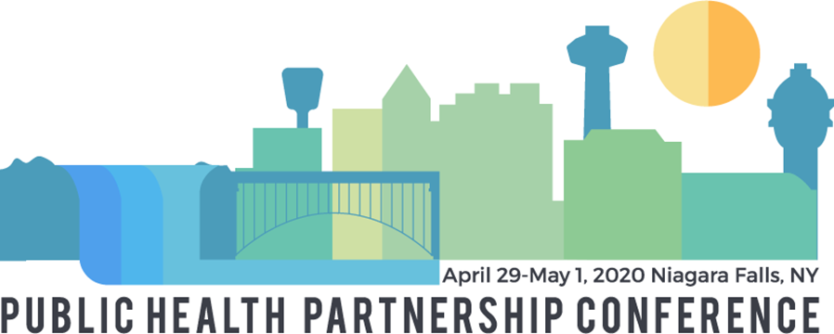
Student Poster Competition Guidelines and Entry Form

Compete with other students from public health programs in New York (and surrounding states) to highlight and share a health promotion/prevention issue with other professionals from across New York.
Posters will be judged by NYSPHA Board and Planning Committee Members on the following criteria: Relevance to the conference theme, engaging for public health professionals, originality, educational value, and overall presentation. Posters will be selected for display at the conference from all submitted entries. Students who are selected to display posters are required to attend in person and will receive a FREE conference registration for Day 2 of the conference (May 1st) and $50 travel stipend. Students who wish to attend Day 1 of the conference (April 30) can register at the discounted student rate of $45.
NOTE: If your poster is selected for display, you must attend the conference to present your poster. Posters will not be displayed without an accompanying student.
Projects must be original student research and cannot have been previously presented at a conference or other public forum.
First, Second, and Third place winners will each receive a free one-year membership to NYSPHA. The First place winner and the school that he/she is representing will be acknowledged on NYSPHA’s website. All winners will be awarded before the luncheon on Friday.
Review the poster guidelines below and complete your entry form today!

GUIDELINES:
Design a poster that has a specific focus in public health; following the theme of the Air, Water, Food: Protecting Where We Live, Work, and Play and on one of the following topic areas:
  - Air (tobacco, asthma, climate change.);
  - Water (drinking water, emerging contaminants, HABs, sugar-sweetened beverages);
  - Food (insecurity, breastfeeding, food safety and sourcing);
  - Housing/Built Environment (lead, walkable communities, complete streets);
  - Environmental Health- Innovations in Policy & Practice; or
  - An area of interest to you and relevant to other conference attendees.

- You will receive email confirmation of this entry form upon submission AND if your poster is selected to be showcased at the conference you will be notified on April 10th 2020.

- Students whose posters are selected for display are expected to present their posters during the oral presentation session on Friday, May 1st.

- Posters should be no larger than 5’ (width). We will provide supplies for you to attach your poster for display.

- Color, design, graphs, charts etc. and overall format is up to the student; however, a portion of the scores will result from overall visual presentation of the poster.

- PLEASE NOTE: Abstracts cannot be accepted via email. All abstracts must be submitted online at https://www.abstractscorecard.com/cfp/submit/login.asp?EventKey=CTSKJFUF. Online submissions are now being accepted. Please submit your entry by 5:00 pm on March 23rd. No late entries will be accepted.

For Questions Contact:
Denise C. Tahara, NYSPHA Vice President, Student Poster Coordinator
Denise_tahara@nymc.edu or call: (914)594-2039

2020 Student Poster Competition Entry Form

Please review all information on the entry form.
We are accepting student poster abstracts for presentations on the following topic areas:
- Air (tobacco, asthma, climate change.)
- Water (drinking water, emerging contaminants, HABs, sugar-sweetened beverages)
- Food (insecurity, breastfeeding, food safety and sourcing)
- Housing/Built Environment (lead, walkable communities, complete streets)
- Environmental Health- Innovations in Policy & Practice
- An area of interest to you and relevant to other conference attendees

Please provide the following information and submit the form information through the portal at https://www.abstractscorecard.com/cfp/submit/login.asp?EventKey=CTSKJFUF.
Date:
Student Name:
Student e-mail:
Student phone #:
Student University/College:
- Topic of your poster:
- Have you displayed or used your poster for another event/class?
- (If yes, where/why?)

Please provide a short paragraph to summarize the topic of your poster (e.g. focus, target audience, hypothesis, findings etc.).

Why should we select your poster to showcase at the 2020 NYSPHA Annual Conference?

Please complete the acknowledgement information below and submit the document through submission portal.

By checking this box, I certify that this is my original work and give permission to display my work, my name, and my photo. I acknowledge that submitted materials are the property of NYSPHA and may not be returned unless requested. I agree that if my poster is selected for display, that I will attend the conference to present my poster. I further agree that my project has not been previously presented at a conference or other public forum.

Topic (Please check one):

☐ Air
☐ Water
☐ Food

☐ Housing/Built Environment
☐ Environmental Health- Innovations in Policy & Practice
☐ An area of interest to you and relevant to other conference attendees

Student Name:

Student’s Institution:

Name and email of Sponsoring Dean or Instructor:

Please submit your entry form online at https://www.abstractscorecard.com/cfp/submit/login.asp?EventKey=CTSKJFUF by or before 5:00 PM on Monday, March 23rd, 2020. We cannot accept submissions via email.

