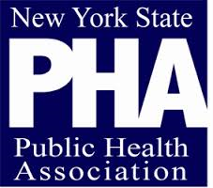

NYSPHA Mentorship Application

Thank you for your interest in NYSPHA’s up and coming mentorship program. We are launching our mentorship program at this year’s Annual Conference, Thursday April 27 at 7:00 PM, coinciding with our evening networking event. At this event, we will provide the opportunity for mentors and mentees to match and we hope you will join us! If you are planning to participate, we will have more information in your registration packet upon arrival to the conference. Please check here if you will be participating in the event: ___________
To help match mentors and mentees, please use this form to tell us a little bit about yourself so that we can best meet your mentor program goals and needs.
*Fields marked with an asterisk are mandatory

Name*______________________________________________________________
Employer____________________________________________________________
Position or Job Title____________________________________________________
Your School (for students) _______________________________________________
Email Address*________________________________________________________
I would like to be a (please check one) * Mentor Mentee
Area of expertise or concentration*__________________________________________
I would like to learn more about______________________________________________
Additional comments or questions___________________________________________
______________________________________________________________________________________

Mentees: Please attach your resume or CV
Mentors: Please provide us with a brief bio

Please return your completed application to denise_tahara@nymc.edu as soon as possible. Subject line: NYSPHA Mentoring Session

